Unit 1. Science and Pseudosience. The scientific Method.

From Kidsearch.com
Science is what we do to find out about the natural world. It is the total of physics, chemistry, biology, geology and astronomy. Science makes use of mathematics, and it makes observations and experiments. Science produces accurate facts, scientific laws and theories. 'Science' also refers to the large amount of knowledge that has been found using this process.
Research uses the scientific method. Scientific research uses hypotheses based on ideas or earlier knowledge. Then those hypotheses are tested by experiments.
People who study and research science and try to find out everything about it are called scientists. Scientists study things by looking at them very carefully, by measuring them, and by doing experiments and tests. Scientists try to explain why things act the way they do, and predict what will happen.
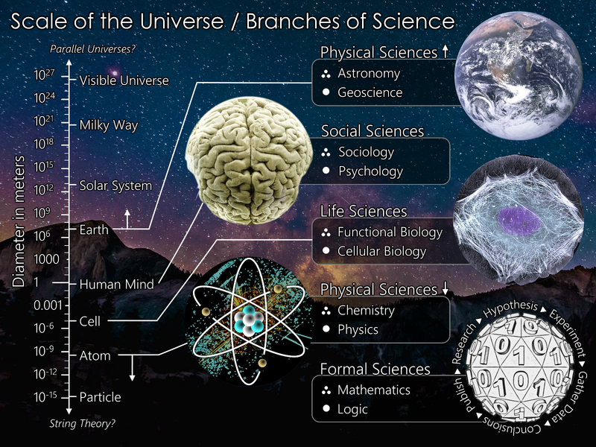

Scientific method
Today, "science" usually refers to a way of pursuing knowledge, not just the knowledge itself. It is mainly about the phenomena of the material world. In the 17th and 18th centuries scientists increasingly sought to formulate knowledge in terms of laws of nature such as Newton's laws of motion. And over the course of the 19th century, the word "science" became increasingly associated with the scientific method itself, as a way to study the natural world, including physics, chemistry, geology and biology.
It is in the 19th century also that the term scientist was created by William Whewell. He meant it to distinguish those who sought knowledge on nature from those who sought other types of knowledge.
The scientific method is the name given to the methods used by scientists to find knowledge. The main features of the scientific method are:
- Scientists identify a question or a problem about nature. Some problems are simple, such as "how many legs do flies have?" and some are very deep, such as "why do objects fall to the ground?"
- Next, scientists investigate the problem. They work at it, collecting facts. Sometimes all it takes is to look carefully.
- Some questions cannot be answered directly. Then scientists suggest ideas, and test them out. They do experiments and collect data.
- Eventually, they figure out what they think is a good answer to the problem. Then they tell people about it.
- Later, other scientists may agree or not agree. They may suggest another answer. They may do more experiments. Anything in science might be revised if we find out the previous solution was not good enough.

Pseudoscience ("false science") is an idea that looks like science, but is not. Pseudoscience may fail one or more parts of science. Sometimes, pseudoscience are ideas that are thought to be wrong.
Essentially, pseudoscience is any idea about how nature works that is generally not accepted as true by the mainstream scientific community. An idea can be considered pseudoscientific for any number of reasons. The word pseudoscience literally means "false science." Creationismand Astrology are both well known pseudosciences.
Pseudoscience is often considered immoral by scientists not because its claims are undemonstrated, but because they are sometimes presented as facts and/or real. An average person might not recognize the differences in credibility between a television program about psychics supposedly reading people's thoughts versus one that presents evidence for and against global warming.

Differences between pseudoscience and science
- Pseudoscientific ideas are not tested, or can not be tested (i.e. not testable). Science ideas are tested, and are testable.
- Pseudoscientific ideas are not given to scientists to read before they go into a paper (called "peer review"). Science papers are peer reviewed.
- Pseudoscientific ideas are not based on facts. Science is based on facts and observations.

Types of Pseudoscience
Ideas (more properly "hypotheses") about how nature works may be considered pseudoscientific for many reasons. Sometimes, the hypothesis is just simply wrong, and can be demonstrated to be wrong. An example of this is the belief that the Earth is flat, or the belief that human female skeletons have one more rib than men do. Ideas such as these are considered pseudoscientific because they are just simply wrong.
Sometimes, scientists agree that a certain idea may be true, but could never be demonstrated to be true, even in principle. For example, some people believe that the Earth and the universe came into existence last Thursday. They believe that when the universe came into existence last Thursday, it was created with the appearance of being many thousands or even millions of years old. According to these believers, even our memories of two weeks ago are actually just the false memories that came along with the creation of the universe, which took place last Thursday. Such a belief is considered pseudoscientific because it is not falsifiable—scientists cannot even imagine an experiment that could shed light on whether this belief is true or false.
Other types of pseudoscience are considered pseudoscientific because they are based on deception, even though the idea being used is not impossible. Examples of this are people who claim to have build time travel devices, antigravity devices, or teleporters. Scientists simply do not have the technology to build such things in modern times, even though they may be able to someday.
Some ideas are arguably pseudoscientific. This means that some mainstream scientists consider the idea pseudoscientific and some do not. Certain ideas about how the stock marketbehaves fall into this category.
Pseudoscience is not exactly the same thing as biased research, where the scientist has some bad motive (such as personal gain, fame, or financial profit) for promoting their findings. It is also not the same as an untested hypothesis, which is an idea that scientists cannot test yet because they do not have the money or technology to do so. The theories of quantum gravity are untested hypotheses: scientists can easily imagine experiments to test them, but they just do not quite have the technology to do so at this time.

