THEORY UNIT LIVING THINGS AND DIVERSITY

It is easy to distinguish between living thins and not living things (inert) because living things do some things like breathing, eating or talking. But, how could you explain what living things are? Not all of them breathe oxygen or move or even talk like you…
This unit is going to give you an idea about what a living thing is by explaining what all living things have in common.
Sometimes, it isn’t easy to assure if something is alive. Think of the famous virus. A virus is just a box (capsule) made up of proteins basically, and it contains a bit of DNA or RNA. It is unable to do anything by himself, it does not breath or eat or reproduce. But it is able to infect a cell by entering it and force the cell to make copies of itself. By doing this the virus usually hurts the cell and sometimes the cell even dies. Scientist don´t agree with the definition of a living or not living virus, it is in the edge between both …

WHAT DO ALL LIVING THINGS HAVE IN COMMON?
Living organisms have many things in common:
- First of all, all living things have to carry out the three vital functions: nutrition, interaction and reproduction.

-Second, living organisms are made up of similar substances: elements and molecules that can be: inorganic (water and minerals) and organic (carbohydrates, lipids, proteins, and nucleic acids). The biomolecules carry out many functions in the organism: to store energy, to form structures, to be part of chemical reactions, and to store the genetic information.

The most common elements that are present in all living organisms are: C, H, O, N, P, S.

-And third, living things are composed of cells, one or more than one; and there are two types, prokaryotic and eukaryotic.

LEVELS OF ORGANIZATION:

So, the cell is the smallest living organism (unicellular organism). When many cells work together, we get a tissue and when many cells are together but work independently, we get a colony.

Some tissues working together form an organ and organs work in systems. Many systems form an organism (in this case multicellular). Organisms form Species that can live in a population and in communities with others. Some communities form a Biocenose and some biotopes form Ecosystems. All ecosystems form the Ecosphere.

But the cells are also formed of organelles, that are formed of biomolecules. As you know, molecules are made up of atoms or elements and the atoms are made up of subatomic particles. Subatomic particles seem to be formed of other subparticles….

Levels of organization of living organisms:
subatomic particles - atoms - molecules - biomolecules - organelles – cell or unicellular living thing - colonies - tissues -organs - systems – organism or multicellular living thing- population -community – biocenose – ecosystem -Ecosphere

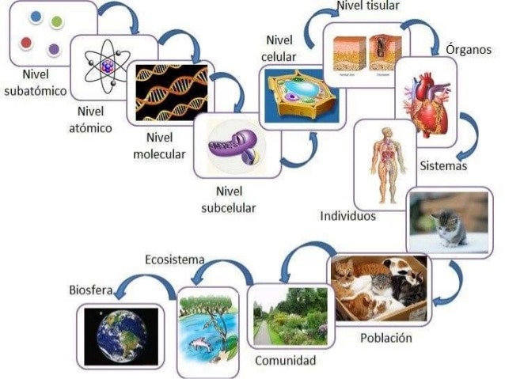

Classification of living organisms: TAXONOMIC RANGES: TAXONOMÍA
Carl Linnaeus developed a system to classify living organisms according to the common characteristics. This system implied 5 KINGDOMS. Kingdoms are formed by other groups of organisms that share some characteristics: the Phyla, and Phyla are formed by other smaller groups called Classes, and so on. The order of groups from the biggest to the smallest is:
Kingdom - Phylum - Class - Order -Family- Genus - Species
How can you remember the order? Use this sentence: "King Phillip Came Over For Good Spaghetti"

THE THREE DOMAIN SYSTEM

As scientists learn more about organisms, classification systems change. Genetic sequencing has given researchers a whole new way of analysing relationships between organisms. The current system, the Three Domain System, groups organisms primarily based on differences in ribosomal RNA (rRNA) structure. Ribosomal RNA is a molecular building block for ribosomes. Under this system, organisms are classified into three domains and six kingdoms. The domains are Archaea, Bacteria, and Eukarya. The kingdoms are Archaebacteria(ancient bacteria), Eubacteria (true bacteria), Protista, Fungi, Plantae, and Animalia.
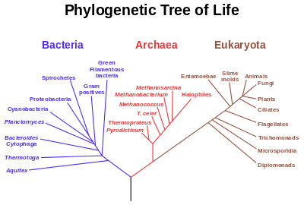

SPECIES: A species is a group of organisms that can reproduce with each other and have offspring that are fertile. A group of similar species form a Genus.
Species have a scientific name formed by the Genus and the Species name: Homo sapiens (Genus is Homo, species is sapiens).

THE 5 KINGDOMS
criteria for kingdom classification: type of cell, number of cells and the type of nutrition.

​1.Monera- Bacteria and Cyanobacteria (Prokaryotic)- Unicellular –Autotrophic or heterotrophic.- Asexual Reproduction

2.Protoctist – Protozoa and Algae -Eukaryotic-Unicelullar and multicellular- No tissues – Autotrophic and heterotrophic - Asexual Reproduction

3.Fungi: Yeasts, Moulds, Mushrooms – eukaryotic-unicellular and multicellular –No tissues –heterotrophic - Asexual Reproduction

4.Plant. Mosses, Ferns, Flowering plants – eukaryotic-multicellular – tissues – autotrophic - Asexual and sexual reproduction

5.Animals: vertebrate and invertebrates- eukaryotic-multicellular –tissues - heterotrophic - Sexual reproduction

KINGDOM | MONERA | PROTOCTIST | FUNGI | PLANTS | ANIMALS
TYPE OF CELL | Procaryotic | Eucaryotic | Eucaryotic | Eucaryotic | Eucaryotic
NUMBER OF CELLS | One. Colonial | One or many. No tissues | One (yeast) o many (mushrooms) | Many, with tissues | Many, with tissues
TYPE OF NUTRITION | Autotrophic y heterotrophic | Autotrophic (Algae)  Heterotrophic (Protozoa) | Heterotrophic, some are decomposers | Autotrophic | Heterotrophic
TYPE OF REPRODUCTION | Asexual | Asexual | Asexual (spores) | Asexual (spores) y sexual (flowers) | Sexual
INTERACTION | Movement | Movement, senses | Movement | Movements, communication | Movements, communication , senses
EXAMPLE | Bacteria | Algas y amebas | Yeast and mushrooms | Mosses, Ferns, pines, flowers | Invertebrates y vertebrates

DIVERSITY

Biodiversity
Biodiversity refers to the variety of living species on Earth, including plants, animals, bacteria, and fungi. While Earth’s biodiversity is so rich that many species have yet to be discovered, many species are being threatened with extinction due to human activities, putting the Earth’s magnificent biodiversity at risk. (National Geographic).
According to Greenfacts:
- Biodiversity is the variability among living organisms from all sources, including terrestrial, marine, and other aquatic ecosystems and the ecological complexes of which they are part; this includes diversity within species, between species, and of ecosystems.
- Biodiversity forms the foundation of the vast array of ecosystem services that critically contribute to human well-being.
- Biodiversity is important in human-managed as well as natural ecosystems.
- Decisions humans make that influence biodiversity affect the well-being of themselves and others.

Biodiversity is the foundation of ecosystem services to which human well-being is intimately linked. No feature of Earth is more complex, dynamic, and varied than the layer of living organisms that occupy its surfaces and its seas, and no feature is experiencing more dramatic change at the hands of humans than this extraordinary, singularly unique feature of Earth. This layer of living organisms—the biosphere—through the collective metabolic activities of its innumerable plants, animals, and microbes physically and chemically unites the atmosphere, geosphere, and hydrosphere into one environmental system within which millions of species, including humans, have thrived. Breathable air, potable water, fertile soils, productive lands, bountiful seas, the equitable climate of Earth’s recent history, and other ecosystem services are manifestations of the workings of life. It follows that large-scale human influences over this biota have tremendous impacts on human well-being. It also follows that the nature of these impacts, good or bad, is within the power of humans to influence

CHARACTERISTICS THAT ALL LIVING THINGS HAVE IN COMMON:

1.-ALL LIVING THINGS ARE MADE UP OF CELLS:

The cell is the smallest unit of life.
Types of cells: Prokaryotic and eukaryotic. Prokaryotic means a simple cell without nucleus or organelles and Eukaryotic means a cell that has organelles and nucleus. Eukaryotic cells are more modern than Prokaryotic cells.
﻿The Cells shape depends on the function the cell carries out in a living organism
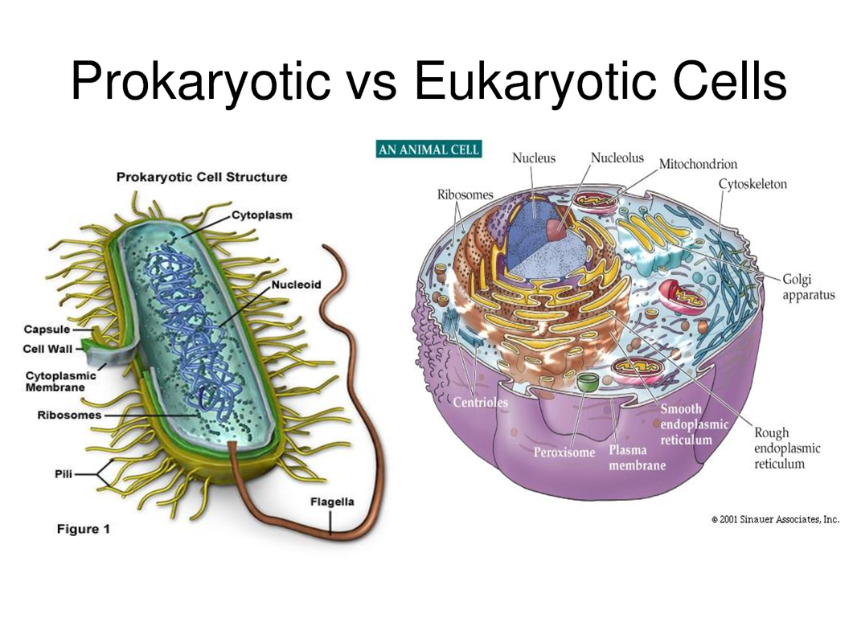
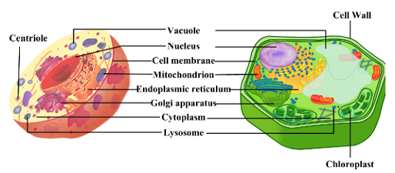

2.-ALL LIVING THINGS PERFORM THE THREE VITAL FUNCTIONS
HOW DO LIVING THINGS FEED?
Nutrition is the combination of some processes: 1.- they feed by taking in materials and energy from the environment, 2.- they transfom this into their own materials, 3.- they eliminate any waste.
Autotrophic nutrition: plants and algae and some bacteria consume inorganic compounds such as water, carbon dioxide and mineral salts and using the sunlight, they produce their own organic compounds. This process is called Photosynthesis and is produced in the chloroplasts.
CO2 + H2O + Sunlight ---------------------- Glucose + O2
Heterotrophic nutrition: animals, fungi, protozoa and some bacteria need to obtain food from other living organisms.
Obtention of energy:
Cell respiration takes place in eukaryotes within the mitochondria. The glucose is burnt out using oxygen to produce energy, carbon dioxide and water.
Glucose + O2 -------------------------------------- Energy + CO2 + H2O

HOW DO LIVING ORGANISMS REPRODUCE? Sexual and asexual reproduction. Sexual reproduction requires two parents that mix their genetic information to produce different descendents, but asexual reproduction requires only one parent that will divide into two or more to produce two or more descendants.

HOW DO LIVING ORGANISMS INTERACT? Living things receive information from the exterior and their bodies (stimuli) and produce a response: cellular movement, or other types of communication.

3.-ALL LIVING THINGS SHARE THE SAME CHEMICAL SUBSTANCES:

The most common elements that form the molecules are C, H, O, N, P, S.
These substances are called biomolecules or nutrients, and can be divided into two categories: Inorganic and organic. There are two Inorganic molecules: Water and Mineral salts. Water is very important for the cell because it forms structures and it's the place where chemical reactions occur. Mineral salts are very different chemicals, they are also involved in chemical reactions and some of them have other functions, such as forming structures (calcium).
There are four organic biomolecules: Carbohydrates, Lipids, Proteins and Nucleic Acids. Carbohydrates are usually sweet, that's why they are also called sugars. The most important ones are glucose, starch and cellulose. Their functions are: to form structures in the cell and to store and give energy to the cell.
Lipids are also called fats. They are very large molecules which functions are to form structures (membranes) and to give and store energy. The fats contain 3 times more energy than the carbohydrates.
Proteins are large molecules with many different functions: to participate in chemical reactions, to form structures, to form hormones, etc.
Nucleic acids are present in all cells because DNA is one of them. The function is to carry the genetic information the cell needs to live.

